

lab mid

Muhammad Hammad Ali Asif



fa22-bse=037

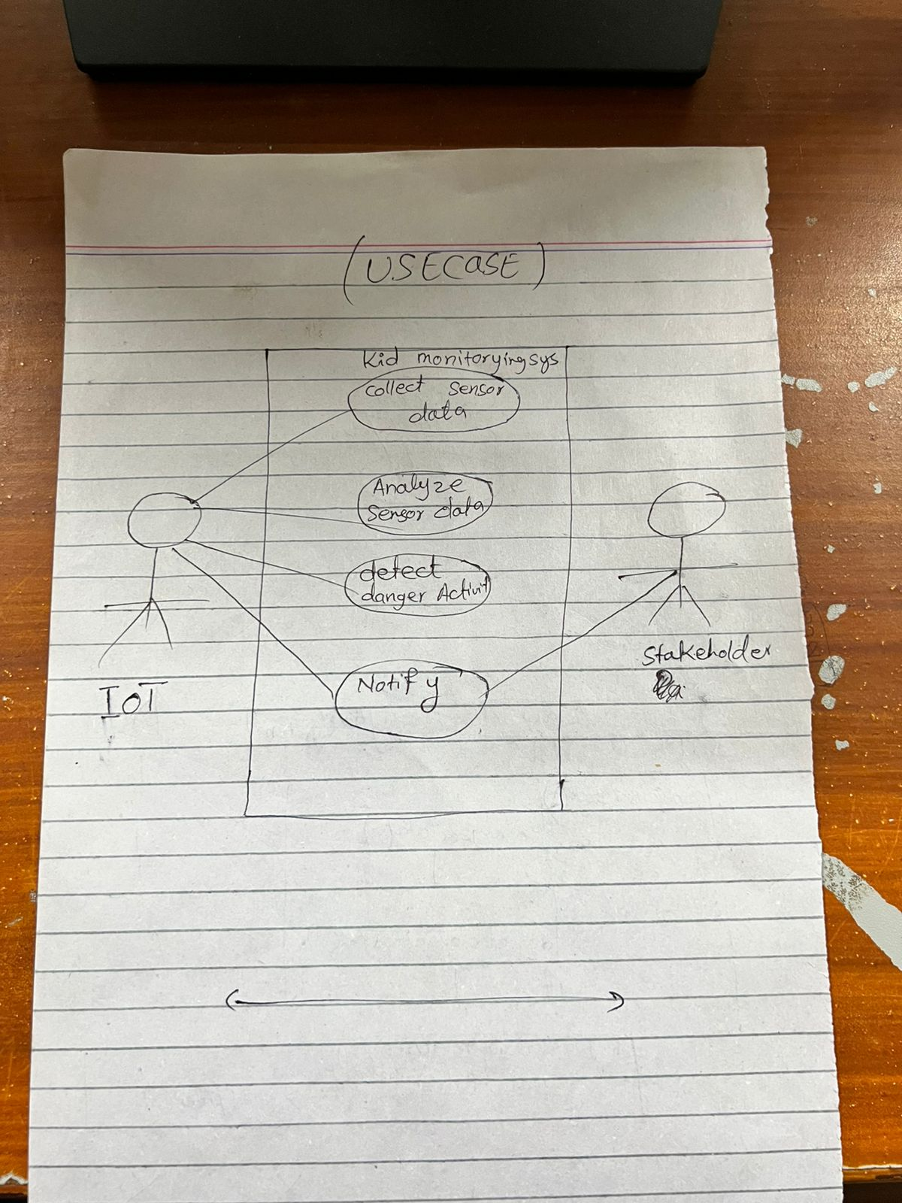

**SOLID Principles**

**Single Responsibility Principle (SRP)**

Each class or module should have only one reason to change.

* Example: Separate classes for data collection, data analysis, and notification services.

#### b. ****Open/Closed Principle (OCP)****

Software entities should be open for extension but closed for modification.

* Example: Add new sensors or new notification types without modifying existing code.

#### c. ****Liskov Substitution Principle (LSP)****

Subtypes must be substitutable for their base types.

* Example: A general Sensor interface could be implemented by MotionSensor, TemperatureSensor, etc.

#### d. ****Interface Segregation Principle (ISP)****

Clients should not be forced to depend on methods they do not use.

### ****Design Patterns****

#### a. ****Observer Pattern****

Used to notify stakeholders when dangerous activity is detected.

* IOT system notifies all observers (e.g., parents, guardians) in real time.

#### b. ****Strategy Pattern****

Used to define different data analysis strategies.

* Different algorithms can be applied for analyzing sensor data.

